Đáp án sách Destination B1 Unit 1
A
1. Helen often eats fast food for lunch.
2. In the evening. Helen usually meets her friends for coffee.
3. Once a week, Helen watches a film at the cinema.
4. Helen rarely goes to the gym.
5. Helen has a driving lesson twice a week.
B
1. is writing
2. are losing
3. is having
4. is staying
5. am not lying
6. is always using
7. are having
8. Are you playing
C
1. Do top musicians study
2. aren’t touching
3. does
4. Is Christine listening
5. usually buy
6. starts
7. Is our team winning?
8. enjoy
D
1. am working
2. don’t go
3. is getting
4. Does Gary ever talk
5. hit
6. read
7. Do you practise
8. are doing
9. knows
10. do you spell
E
1. bmove
2. Are/watching
3. helps
4. am using
5. Does/do
6. Do/have
7. aren’t holding
8. belongs
F
1. am loving/ love
2. are throwing/throw
3. is seeming/seems
4. are needing/need
5. are taking/take
6. are winning/win
7. are preferring/prefer
8. am not understanding/don’t understand
9. wait/am waiting
10. does/is doing
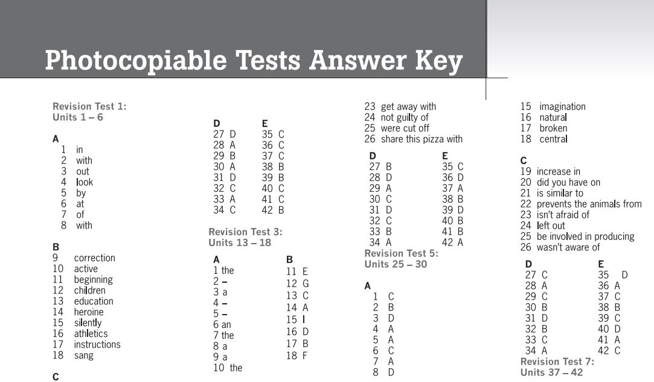

Đáp án sách Destination B1 Unit 2
A
- sent
- didn’t come
- made
- knew
- took
- gave
- went
- had
B
- I bought one yesterday
- I was/went there two years ago
- I did/finished it last night
- I sold it in June
- I broke a/the window a week ago
C
- was playing
- was sleeping/ was listening
- was standing
- was working/ was leaving
- Were/having
- was running
- was/going
- were watching
D
- went
- decided
- was having
- was raining
- were arguing

- called
- were eating
- was making
- was dreaming
- was practising
E
- woke
- was shining
- were singing
- was
- went
- was having
- said
- continued
- put
- opened
- was getting
- rang
- answered
- was practising
F
- used to
- Did/use to
- used to
- Didn’t use to/ never used to
- Did/use to
- didn’t use to/ never used to

Đáp án sách Destination B1 Unit 3
A
Across
- champion
- gym
- coach
- referee
- support
- folk
Down
- member
- opponent
- cheat
- group
- risk
B
- scoring
- beating
- interests
- have fun
- organise
- challenge
- train
C
- board
- captain
- pleasure
- concert
- team
- classical
D
- B

- A
- C
- A
- C
- A
- C
- A
E
- for
- on
- in
- on
- in
- for
F
- song
- musical
- athletics
- children
- actor
- collection
- sail
- musician
G
- playful
- athletic
- actions
- entertainment
- heroic

- childhood
H
- with
- like
- by
- about
- in
- at
- with
I
- about
- to
- on
- against
- of
- in

Đáp án sách Destination B1 Unit 4
A
- Have seen
- have had
- hasn’t taken
- has been
- Have you ridden
- has made
- haven’t decided
- Has Paul ever met
B
- A
- B
- A
- B
- A
- A
- B
- A
C
- The lesson hasn’t started yet.
- The teacher has already written on the board.
- Joe and Tim have just come into the classroom.
- Tony hasn’t finished getting his books ready.
- Christine has already opened her book.
- Dave has dropped pen on the floor.
- He hasn’t picked it up yet.
D
- have you been doing
- I’ve been studying
- Have you been working
- I’ve just been sitting
- I haven’t been going
- I’ve been working
- I’ve been painting
- we’ve also been planning
- We’ve been looking.
- I’ve been thinking
E
- heard
- arrived
- been writing
- been talking
- invited
- been reading
- been playing
F
- yet
- for
- ever
- already
- since
- just
- never

Đáp án sách Destination B1 Unit 5
A
- had left
- had already seen
- hadn’t finished
- Had you just spoken
- we’d set off
- I’d already eaten
- Had you heard
B
- B
- A
- A
- B
- A
- A
- B
C
- We’d just heard the news when you rang.
- I’d already thought of that before you suggested it.
- When I turned on the TV, the programme had already started.
- She was hungry because she hadn’t eaten anything all day.
- By the time I left school, I’d decided to become a musician.
D
- she’d been running
- they’d been dancing
- it had been raining all night
- they’d been driving too fast
- they’d been waiting for over half an hour
- they hadn’t been waiting long
E
- B
- A
- A
- B
- B
- A
F
- been
- had
- ✓
- had
- ✓
- making
- ✓
- been
- yet

